
ASSESsING ISSUES AROUND
POVERTY IN NIGERIA

A RESEACH PROJECT BY TEAM 8 STUDENTS,
DATA SCIENCE TRACK AT AISATURDAYS COHORT 4,
UNIVERSITY OF LAGOS, LAGOS, NIGERIA
DECEMBER, 2019
Table of Contents

- Title Page 0
- Table of Contents 1

Overview 2
- Socio-demographics of the respondents 3
- Assessing the rate of employment in Nigeria 6
- Salary earnings per month 7
- Income from other sources 8
- Job satisfaction across salary ranges 9
- Incomes Satisfaction 10
- Major Expenses Incurred by Nigerians 11
- Level of tax payment 12
- Major desires to own assets 13
- Perception of People about the Country 14
- Perception of People about the Government 15

Recommendations 15
Conclusions 15

Appendix
Appendix 1: Questionnaire 16
Appendix 2: Project Team 17

Overview

This report provides insights into issues around poverty in Nigeria. It takes information from a questionnaire administered to over 300 respondents in Nigeria. The survey specifically focused on the following objectives:
- Socio-demographics of the respondents
- Assessing the rate of employment in Nigeria
- Salary earnings per month
- Income from other sources
- Job satisfaction across salary ranges
- Incomes Satisfaction
- Major Expenses Incurred by Nigerians
- Level of tax payment
- Major desires to own assets

At the end, it looks at the perception of the people about the country and government. It suggests recommendations as possible strategies in ameliorating the negative consequences of poverty in the country.

- Socio-demographics Distribution of the Respondents
This section clearly portrays the socio-demographic characteristics of the respondents using data visualization methodology. In achieving this, eight major variables have been selected from the actual data set. They include Nationality, Gender, Age Group, Marital status, Number of kids, State of Residence, Location type and Occupations. Figures 1 to 8 present the summary of the participant’s socio-demographic data.

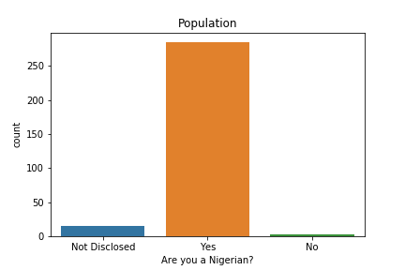
Fig. 1: Nationality of the Respondents

It is observed from the Figure 1 that the majority of the respondents are Nigerians which accounts for 285(94.0%) of total participants, Non-Nigerians account for 3(1.0%), while 15(5.0%) respondents did not reveal their nationality identity. The result suggests that more Nigerians participated in this survey.

With respect to Gender, Figure 2 shows that 216(70.0%) of total respondents were males while 86(30.0%) were females. This suggests that more males participated in this study than their female counterparts.

Looking at respondent’s age groups, it is observed that 181(60.0%) of total respondent were 18-25 years of age, 104(34.0%) were 26-35 years, 13(4.0%) were 36-45 years, while 4(1.0%) were 46-55 years. The modal and least age groups were 18-25 and 56-65 respectively.

In Figure 34(10.0%) of total respondents were married while 269(90.0%) were not. Also, in Figure 24(10.0%) of total respondents have kids while 279(90.0%) do not have. In Figure 6, majority of the respondents 229(76.0%) reside in Lagos, followed by Ogun state with 18(6.0%) while states such as Abia, Akwa Ibom, Benue, Nasarawa, Niger and Plateau had one respondent each. The result shows that respondents cut across twenty states in Nigeria.
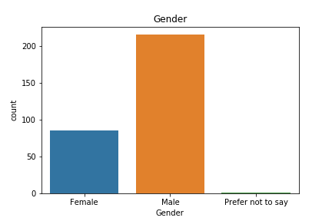
Fig. 2: Gender of the Respondents

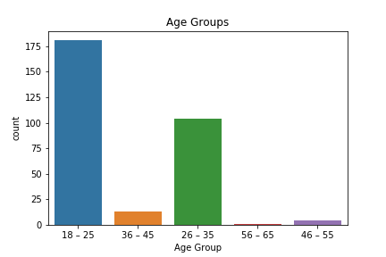
Fig. 3: Age Groups of the Respondents

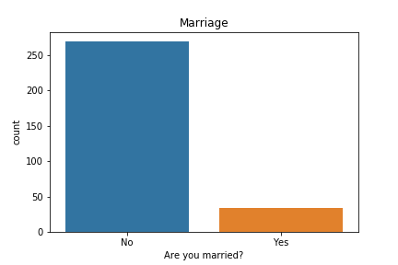
Fig. 4: Marital Status of the Respondents
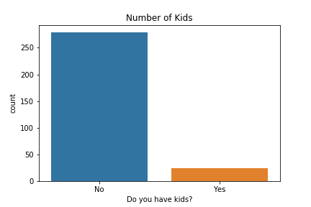

Fig. 5: Marital Status of the Respondents
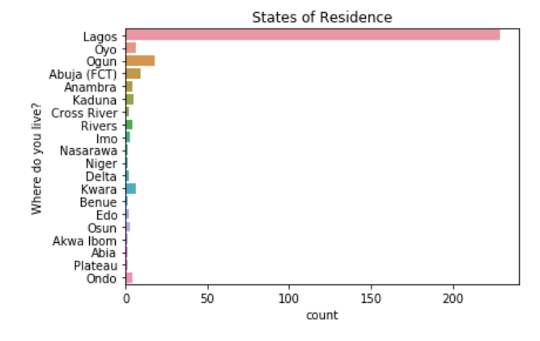

Fig. 6: States of Residence of the Respondents

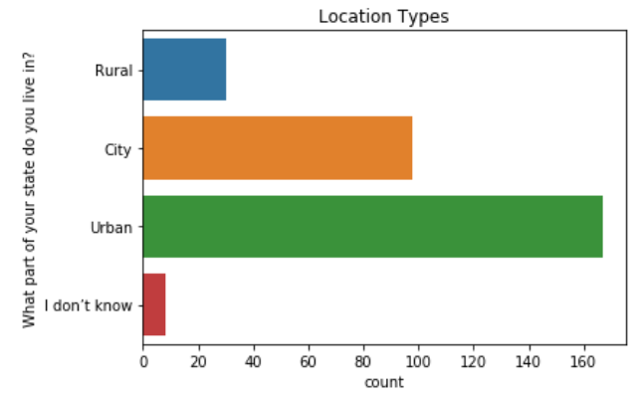

Fig. 7: Location types of the Respondents
It was shown in Figure 7 that majority of the respondents 167(55.0%) were located in Urban areas, followed by 98(32.0%) of respondents in cities, 30(10.0%) were located in Rural areas while 8(3.0%) preferred not to disclose their location identities.

According to Figure 8, it shows the various occupation types of the respondents. Quite a number of respondents 50(7.0%) have ICT related occupations. This is largely followed by a pool of students 48(6.0%). Only a person belonged to farming category.

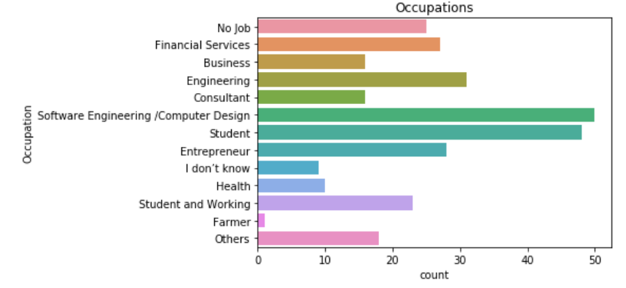
Fig. 8: Location types of the Respondents

- Assessing the Rate of Employment in Nigeria
From Figure 8, the result shows that the people with no job accounted for 25(8.0%). If this number is added to the respondents in student category 48(6.0%), it means the employment rate among the respondents is 86%.

- Salary Earnings per Month (from the Main Occupation)

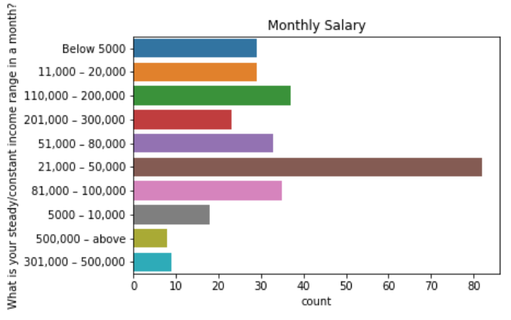

Fig. 9: Monthly Salary of the Respondents

From Figure 9, the highest number of respondents 82(27.0%) collect salaries of range N(21,000:00 – 50,000:00) while the respondents in the least category 8(3.0%) collect monthly salaries that is N500,000.00 and above. It is unfortunate to note that 29(10.0%) of the respondents collect monthly salaries that are below N5,000.00.

With the World Bank’s International Poverty Line which has a value of US$1.90 (N693.50) per day, the survey shows that 26% of respondents live below the international poverty level.

- Income from Others Sources

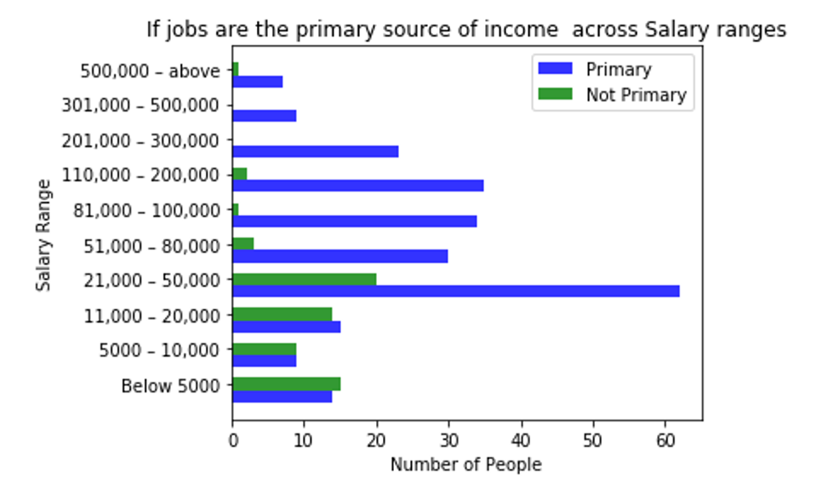
Fig. 10: Monthly Salary of the Respondents

From Fig. 10, it can be deduced that respondents with salary range of N(21,000:00 – 50,000:00) earn their incomes from their main jobs or occupations. This is followed by the others with the exception of respondents who are earning below 11,000.

- Job Satisfaction Across Salary Ranges

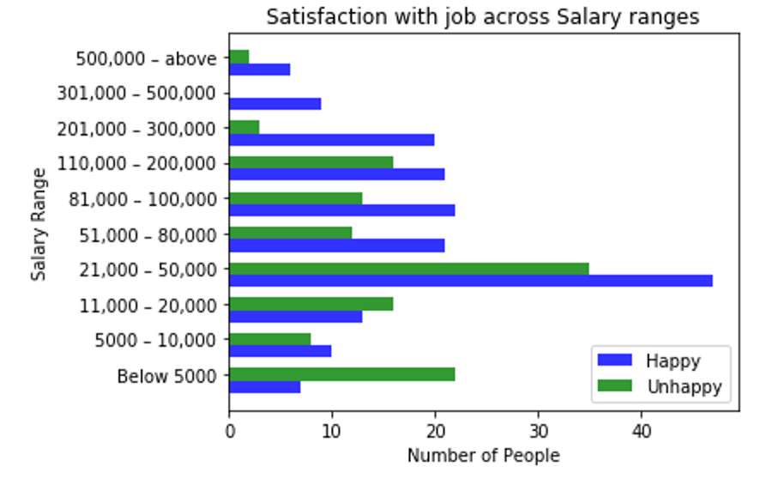
Fig. 10: Satisfaction with Job across Salary Ranges

From Fig. 10, the survey shows that the majority of respondents, with the exception of those in monthly salary ranges of N(10,000:00 – 20,000) and below N5,000:00, are happy with their jobs. Despite the fact that people of lower incomes are also happy with their salary, the survey also shows a huge gap between the high-income earners and low-income earners. This could have been attributed to a number of factors such as level of education, job sector, years of experience and a host of others.

- Incomes Satisfaction

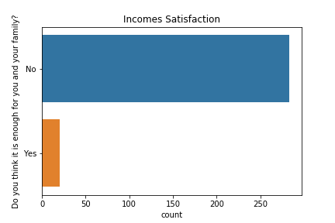
Fig. 11: Incomes Satisfaction

Due to the high level of job un-satisfaction, the survey discovered that the respondents are also involved in some other forms of generating incomes. Some of these include freelancing, buying and selling, contracting and betting (Bet Naija). Despite these other sources of incomes, Fig. 11 shows that majority of the respondents 283(93.0%) still affirmed that they were not satisfied with the level of their incomes. Some of the implications of these are that: the concerned may not be able to take good care of their dependents, some others may be frustrated while others may result to social vices such as stealing, kidnapping, lying, etc.

- Major Expenses Incurred by Nigerians

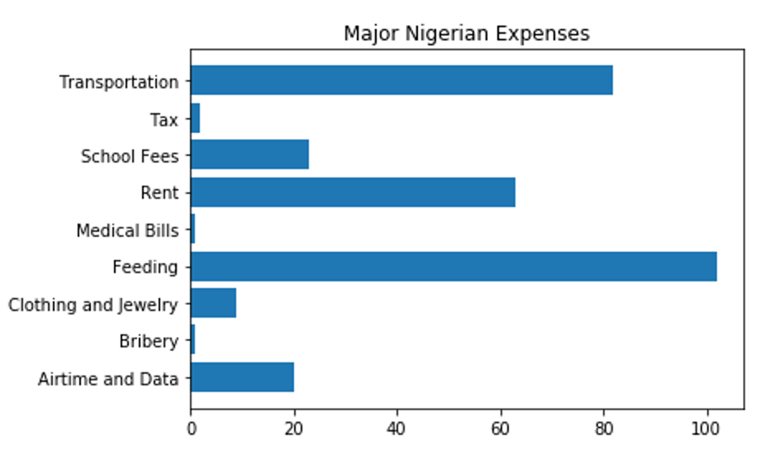
Fig. 12: Major Expenses Incurred by Nigerians

Fig. 12 shows that majority of Nigerians spent the largest percentage of their incomes on feedings, closely followed by transportation and rents. Minimal amount of incomes was being spent on medical bills, bribery and tax payment.

- Level of Tax Payment

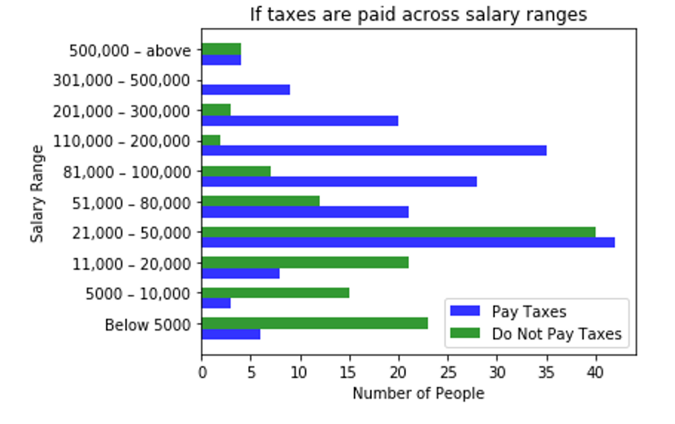
Fig. 13: Tax Payment along Salary ranges

From Fig. 13, the survey shows that the majority of respondents, with the exception of those in monthly salary ranges of N(10,000:00 – 20,000), N(5,000:00 – 10,000) and below N5,000:00, are tax payers. The inability of the latter to pay their pax may be as a result of their low or deficit net incomes.

- Major Desires for Enhancing Standard of Living

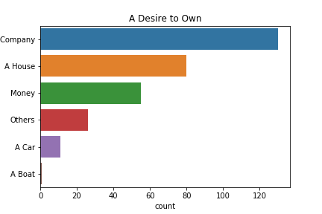
Fig. 14: Desired to Own Assets

From Fig. 14, majority of the respondents 130(43.0%) have strong desires to have companies so that they can be able to stand on their own and also foot their own bills. Very few people 11(4.0%) desired to have cars as their assets.

- Perception of People about the Country

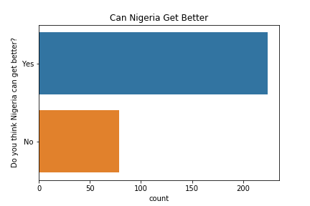
Fig. 15: Perception about Nigeria

From Fig. 15, despite the present dwelling socio-economic status of the country, majority of the respondents 224(74.0%) strongly believe in the turn-around of the country in the nearest future.

- Perception of People about the Government
The respondents described the prevailing poverty level in Nigeria to the ways and manners in which government functionaries have been managing the socio-economic affairs of the country. Some described these functionaries as greedy, dull, not accountable to the citizens, corrupt people being led by inconsiderate fellows, careless about the welfare of the citizens, insensitive, clueless, heartless, disrespectful to the rule of law, nepotic, directionless, unpatriotic, manipulative, looters, and indifferent set of leaders.

Recommendations
Based on the outcomes of this survey, we would like to recommend the following to the government and other policy makers in order to strengthen the socio-economic well-being of Nigerian residents:

- The current economic level of majority of respondents are low. Thus, the government need to come up with workable policies that will usher-in the economic prosperity of Nigerian residents.
- People should be economically empowered in order to earn more legally and thus pay more taxes into the covers of governments.
- Palliative measures should be made available to the frustrated and/or jobless residents.
- Government should help in diversifying the economy in other for the residents to have more economic powers.
- There should be provision of infrastructures for the residents. This will help the existing SMEs to grow and stimulate more other ones to be established.
- Nigerians spend most of their incomes on feeding, transportation and house rents. All these and many more social services should be subsidized by the government in order to lessen their costs on the residents.

Conclusion
We strongly believe that if the insights provided by the analysis of this survey are put into use, it will go a long way in changing the fortune of Nigerian residents to change, increase the standard of living, reducing the negative effects of poverty and position Nigeria better in the comity of nations.

Appendix

Appendix 1: Questionnaire

- Are you a Nigerian?
- Gender
- Age Group
- Are you married?
- Do you have kids?
- Where do you live?
- What part of your state do you live in?
- Occupation
- Are you Happy with your job?
- Is this your primary source of income?
- What is your steady/constant income range in a month?
- Do you think it is enough for you and your family?
- What are your other sources of income?
- Do you pay your tax?
- What is your largest form of expense?
- If there was one thing you really wanted to own, what would that be?
- How much do you think you earn from all other sources of income in a month?
- On an average, how much do you think you spend in a month?
- Do you think Nigeria can get better?
- In a short sentence, describe your government

Appendix 2: Project Team

1. Popoola Isiaka Olamilekan - popoolaio@gmail.com Team Lead
2. Kosisochukwu Akaeze - Kossyfab@gmail.com
3. Henry Adeyemi - deyemihenry11@gmail.com
4. Temitayo Olanrewaju - olanrewaju1temitayo@gmail.com
5. Saheed Adetomiwa - adetomiwasaheed1436@gmail.com
6. Abiodun Quadri - biodundj@yahoo.com
7. Oluwaseun Adepegba - seun.adepegba@gmail.com
8. Ehinloju Nike - nikeehinloju@gmail.com

